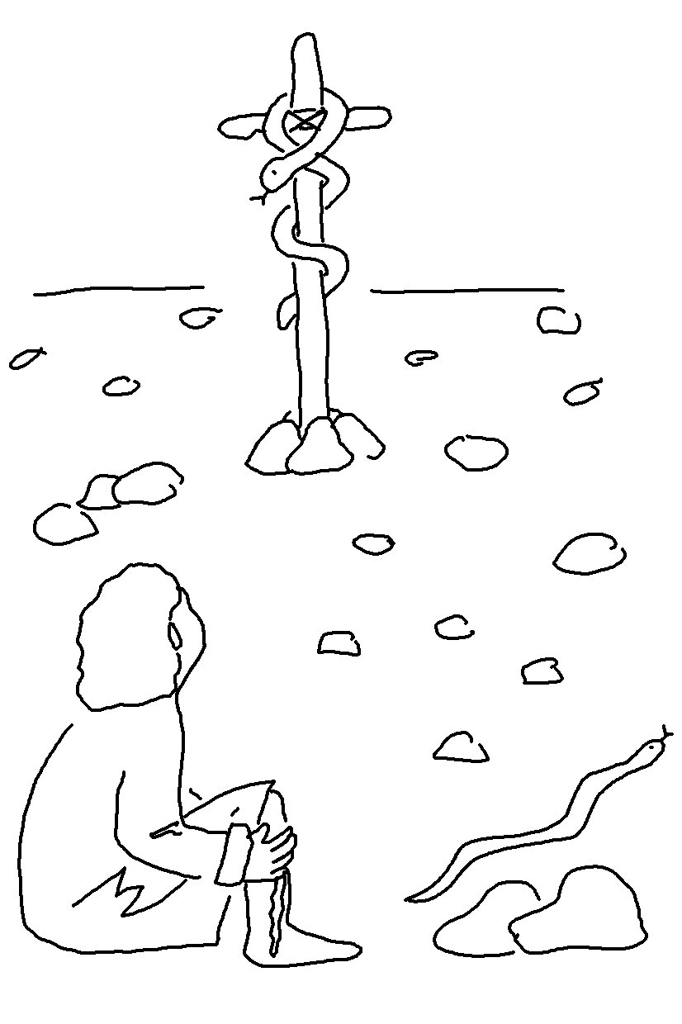
In John 12:32_{NLT} Jesus said, "And when _ am _ _ _ _ _ _ up from the earth, I will draw everyone to myself."

